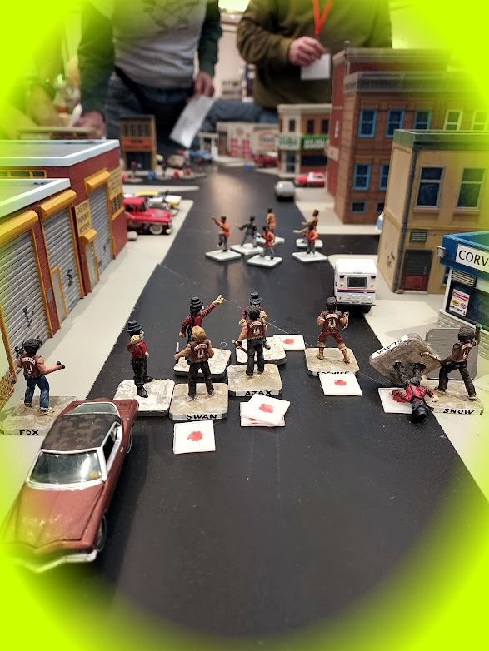
The Warriors (1979) by Cat
Havoc is the premiere miniatures convention in the northeast and has been running for 39 years. Sponsored by BGBoston Inc. (“BattleGroup Boston”),
Havoc XL will be held March 27-29, 2026
Best Western Royal Plaza Hotel
181 Boston Post Rd W. Marlborough, MA 01752

Visit our web site at http://havoc.battlegroupboston.org/

Signup to Attend at:
https://tabletop.events/conventions/havoc-xxxx-2026-
You can also get periodic news and about Havoc by joining our email list at https://groups.io/g/bgb
Or visit our Facebook page: https://www.facebook.com/groups/bgbhavoc

