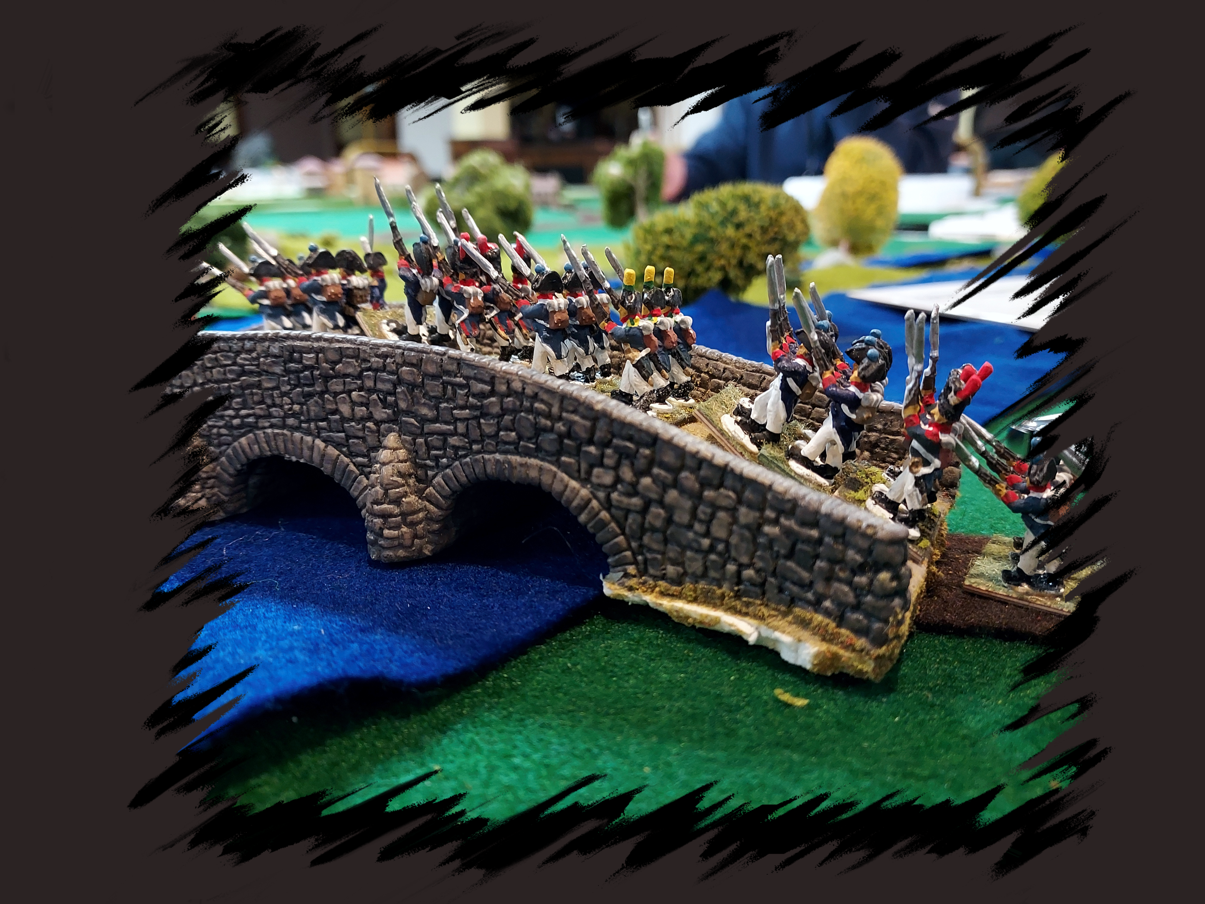

Battle of Echlingen 1805 by James Machin
Havoc is the premiere miniatures convention in the northeast and has been running for 36 years. Sponsored by BGBoston Inc. (“BattleGroup Boston”),
Havoc XXXVI will be held March 31-April 2, 2023
Best Western Royal Plaza Hotel
181 Boston Post Rd W. Marlborough, MA 01752

Visit our web site at http://havoc.battlegroupboston.org/
You can also get periodic news and about Havoc by joining our email list at https://groups.io/g/bgb
Or visit our Facebook page: https://www.facebook.com/groups/1854660101530451

