
HAVOC XXXV

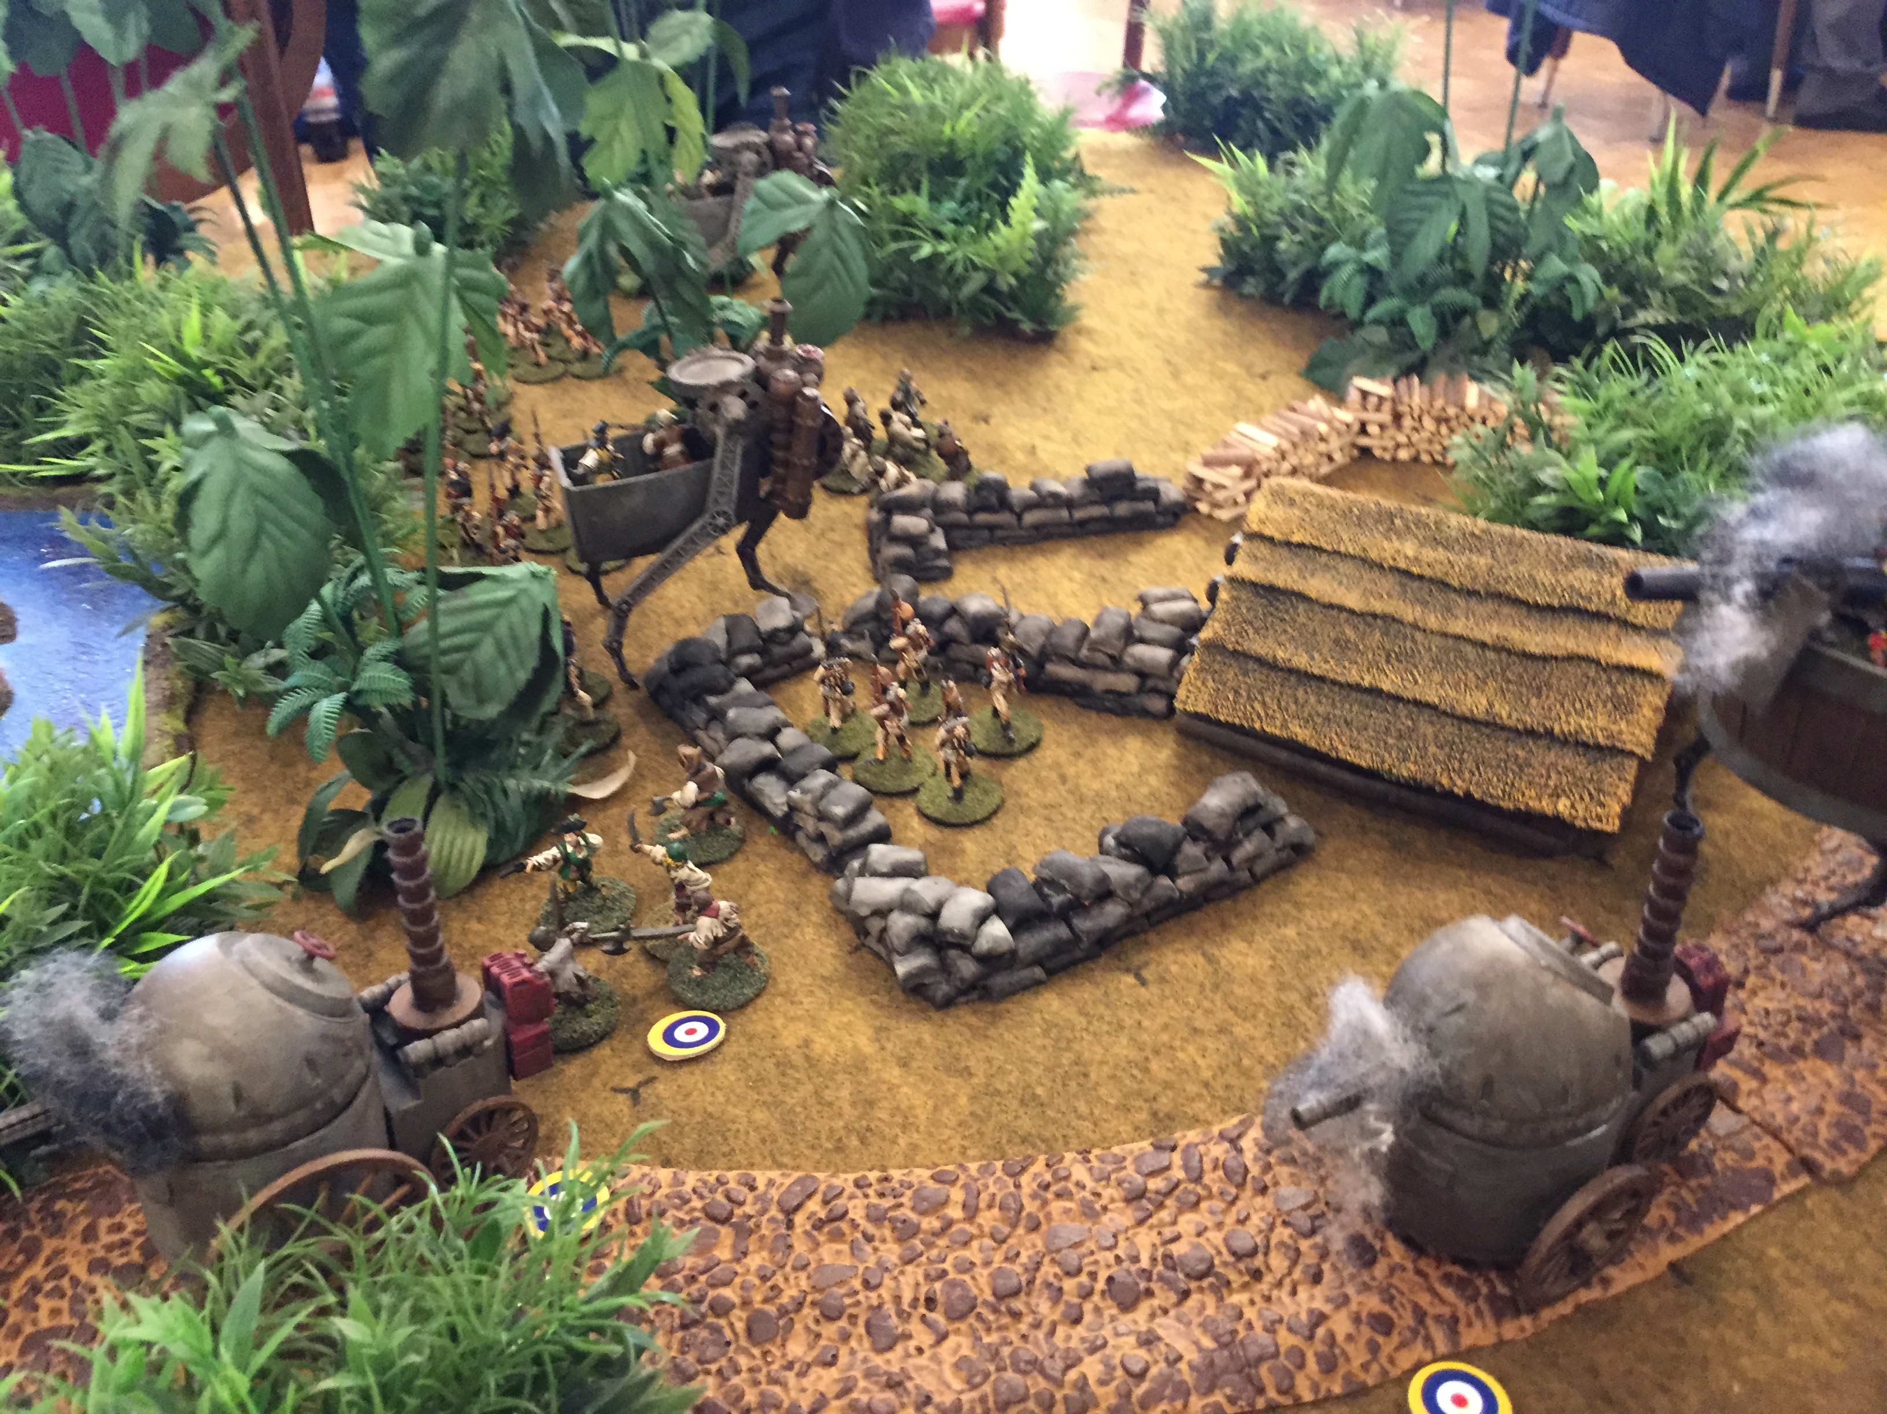
We’re not dead yet!
Havoc is the premiere miniatures convention of the Northeast and has been running continuously for 34 years. Sponsored by BGBoston Inc. (“BattleGroup Boston”), Havoc XXXV will be held April 5 - 7, 2019 at Maironis Park, Shrewsbury MA.

Visit our web site at http://havoc.battlegroupboston.org/
You can also send an email to Havoc-Info-subscribe@yahoogroups.com to sign up to receive updates on the Havoc convention including new events, canceled events, and general information. * Picture from Steam Punk & Victorian Sci-fi, by Gabriel Landowski Winner: Best of Convention award Havoc 34, April 2018

